PRODUCT DETAILS

**Hugo Boss Watch 1502564**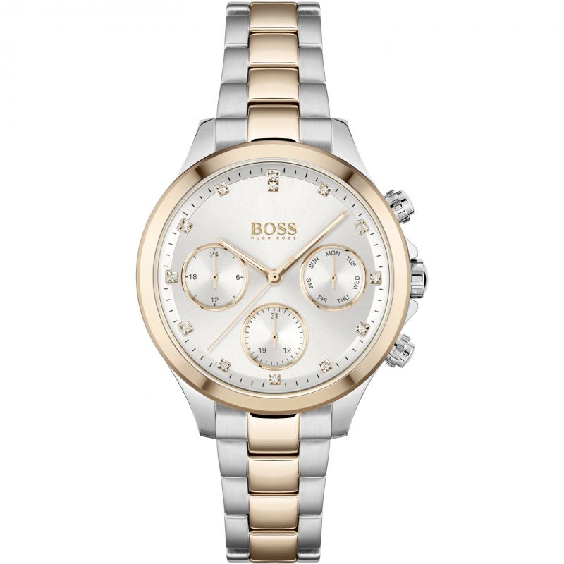

**£199.00**

**Specifications**

**Brand**: Hugo Boss

**Analogue/Digital**: Analogue

**Case** **depth** **approx**.: 10.30mm

**Primary** **Material**: Plated Stainless Steel

**Case** **Shape**: Circle

**Case** **width** **approx**.: 38.00mm

**Clasp** **type**: Deployment

**Dial** **Colour**: Silver

**Multiple** **Time** **Zones** **Display**: Dual Time

**Gender**: Ladies

**Glass**: Mineral

**Hour** **Markers**: Stone Markers

**Model** **Collection**: Hera

**Model** **Name**: Hera

**Movement** **Source**: Swiss

**Movement**: Quartz Multifunction

**Strap** **colour**: Multicolour

**Strap** **Type**: Metal bracelet

**Water** **Resistance**: 30 metres

**Weight (g)**: 94.00

**BARCODE**: 7613272416283

**Guarantee**: 2 years